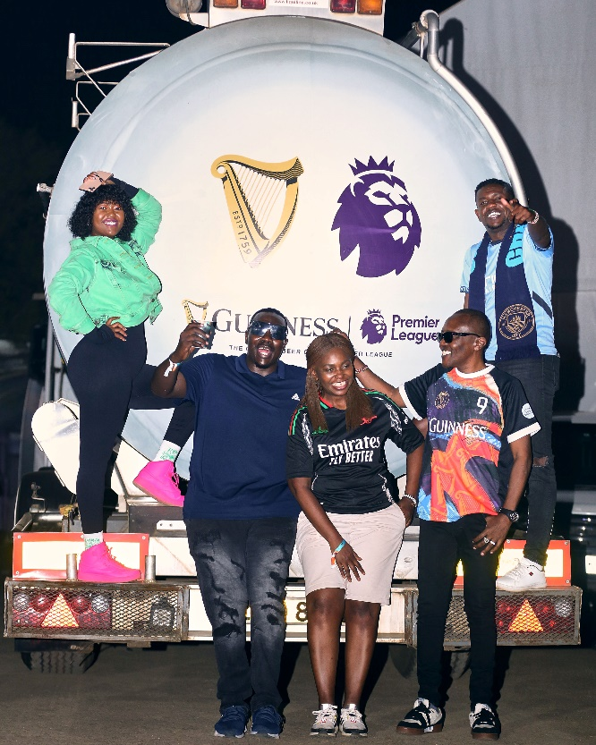**Guinness Kisumu Matchday Experience – PHOTO CAPTIONS**

**Photo 1(**IMG2293**)**: From left: Chief Snacks Officer Nana Owiti, Maina Kageni, Willis Raburu, Director for Drinks Analysis Carol Radull, Matchday Host Maina Kageni, and Chief Entertainment Officer Lotan Salapei share a moment at the Guinness Matchday, Black Pearl Lounge, Kisumu on August 17th and 18th.

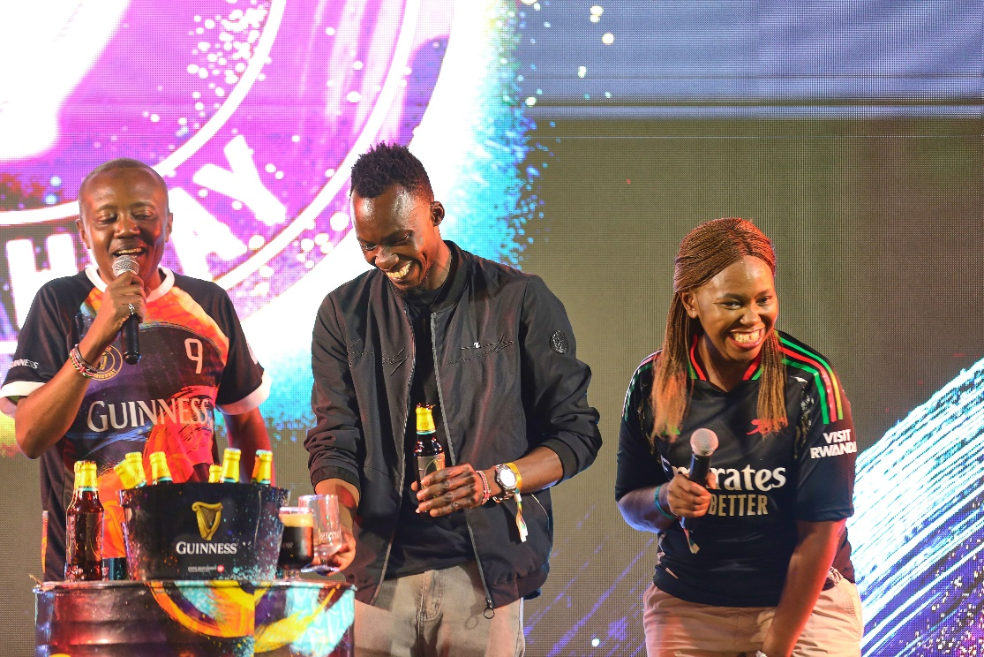

**Photo 2(**IMG2107**)**: From left: Matchday host Maina Kageni, Guinness Perfect Pour Challenge winner Briane Onyogo, and Guinness Director for Drinks Analysis Carol Radull at the Guinness Matchday, Black Pearl Lounge, Kisumu on August 17th and 18th.

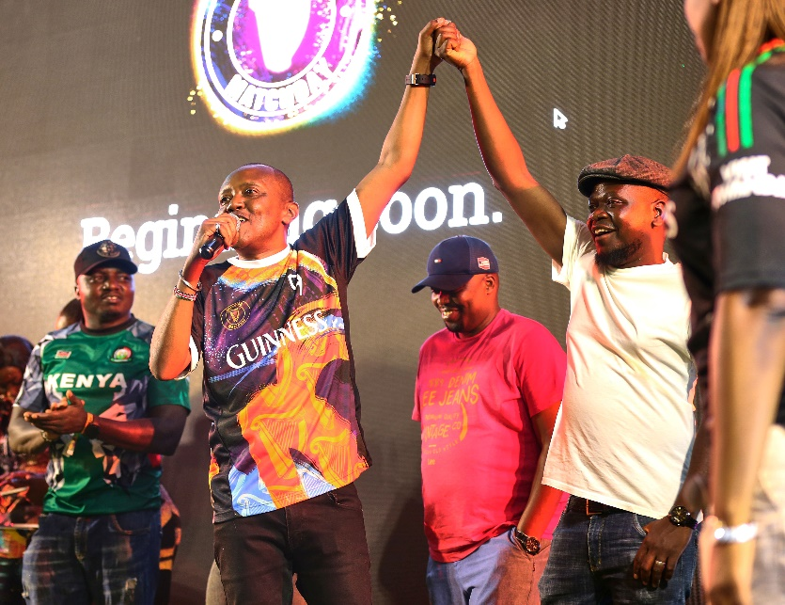

**Photo 3(**IMG2163**)**: From left: Matchday host Maina Kageni and a Guinness Clean Sheet Challenge participant celebrate during Guinness Matchday, Black Pearl Lounge in Kisumu on August 17th and 18th.

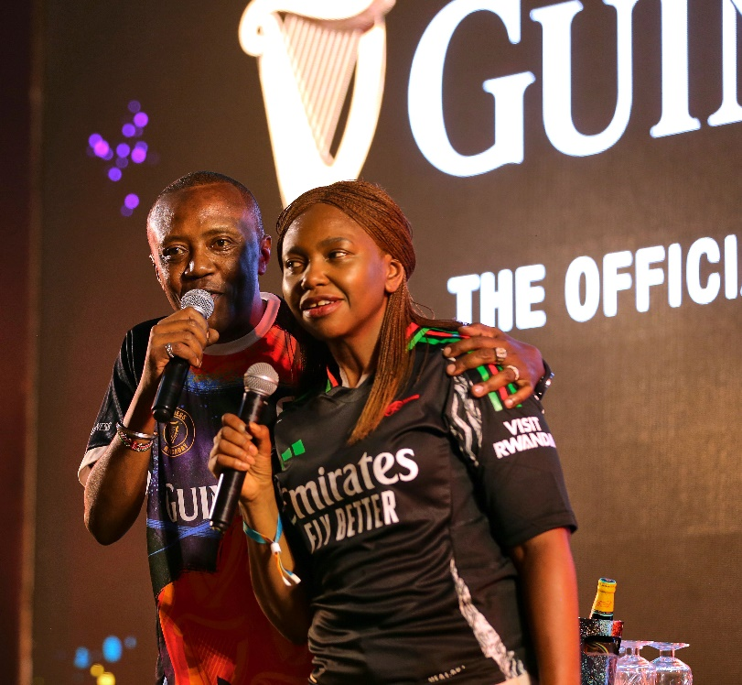

**Photo 4(**IMG2069**)**: Guinness Matchday Host Maina Kageni and Director for Drinks Analysis Carol Radull amp up the fans at the Guinness Matchday, Black Pearl Lounge in Kisumu on August 17th and 18th.

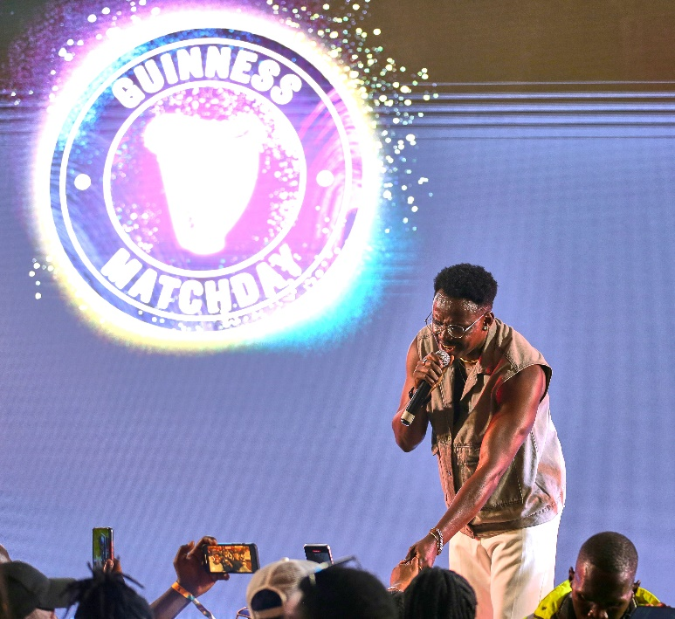

**Photo 6(**IMG2383): Celebrated musician, Okello Max, entertains the crowd at the Guinness Matchday, Black Pearl Lounge in Kisumu on August 17th and 18th.

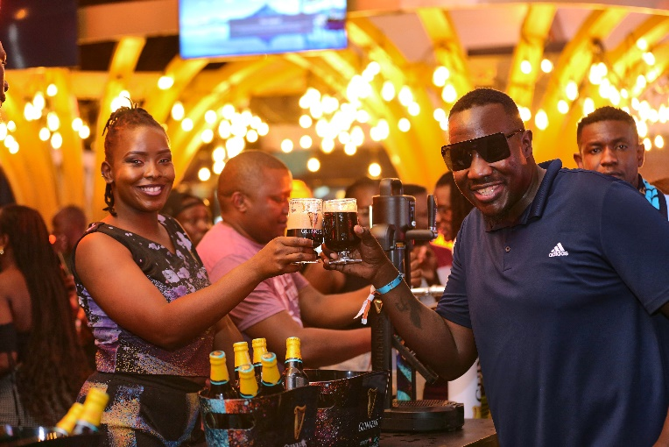

**Photo 7(**IMG 2306**):** Guinness Matchday Committee member Willis Raburu shares a toast with a Guinness Brand Ambassador at the Guinness Matchday, Black Pearl Lounge in Kisumu on August 17th and 18th.

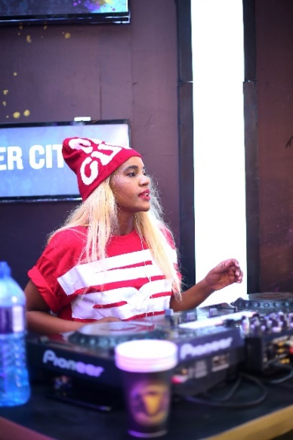

**Photo 7(**IMG 2333**):** Decks master DJ Pierra entertains Guinness Matchday fans at the Guinness Matchday, Black Pearl Lounge in Kisumu on August 17th and 18th.

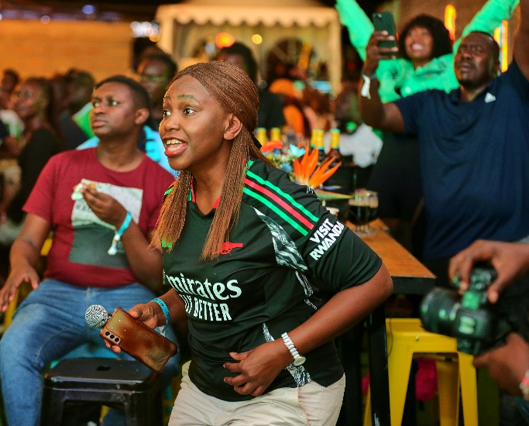

**Photo 8** (IMG 2056): Guinness Matchday Committe’s Carol Radull reacts to the Chelsea Vs Man City game during the live screening at the Guinness Matchday, Black Pearl Lounge in Kisumu on August 17th and 18th.

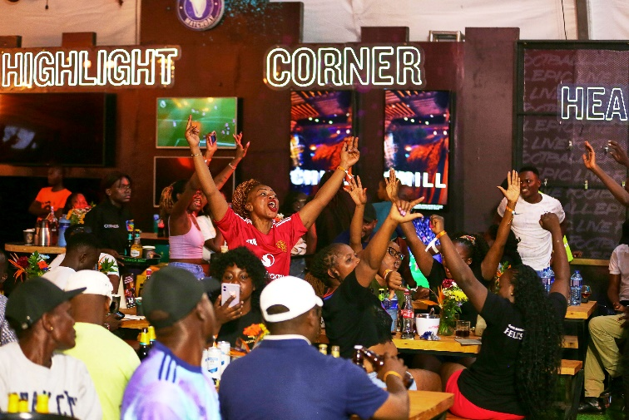

**Photo 9** (IMG 2167) A fan reacts to a game during the live screening at the Guinness Matchday, Black Pearl Lounge in Kisumu on August 17th and 18th.